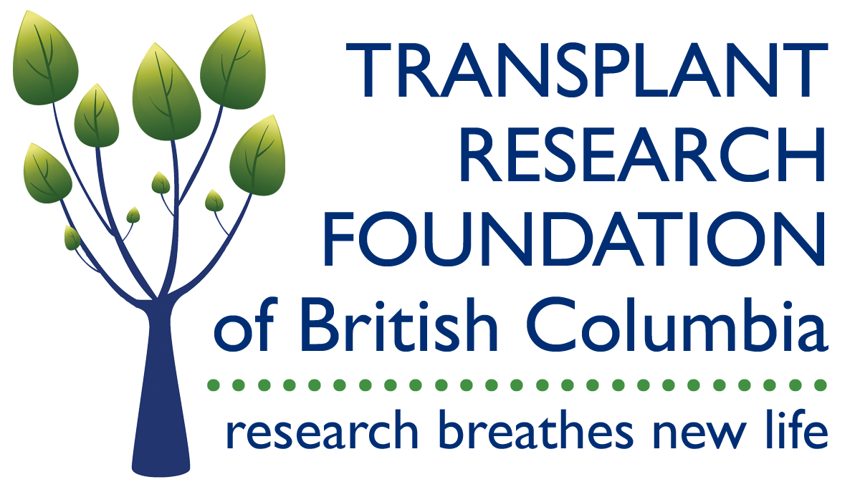

National Child Health Transplant Team Grant Application Form
2016

1. Team Grant Project Title:

2. Team Leads (add lines as needed)
Name of Team Lead  (Underline Surname) | Position/rank, department and/or faculty | Mailing address, telephone and email address
3a. Are any of the Team Leads a Canadian National Transplant Research Program (CNTRP) Researcher?

Yes (place a * beside name(s) above) No

3b. If not, name(s) of team member(s) that are a CNTRP Researcher:

4. Provide the names of 3 to 5 CNTRP Researchers that you suggest as a potential reviewer for your application. We will consider these names as potential members of our peer review committee; however, we cannot guarantee that these individuals will be selected:

5. Provide the names of Individuals that you think would be in conflict and should NOT review your application.

For the following sections 6 to 10, use Times New Roman or Arial font, size 11 points or larger. Use at least 0.75 inch margins (top, bottom, left, and right) for all pages. The section name and the surnames of the Team Leads should appear in the header.

6. Attach a Summary of the Research Proposal that highlights how the research proposal addresses the theme of improving outcomes for pediatric transplant patients. This summary will be used to assess relevance of the application to the scope of the competition. Applications that are not deemed eligible will be removed from the competition and will not be reviewed. Maximum length: 1 page.

7. Attach the Research Proposal. Suggested headings include 1) Statement of objective(s), 2) Brief review of literature and background information, 3) Recent relevant research by applicants, 4) Description of the research team 5) Hypothesis(es), 6) Design and methodology, including data analysis 7) Anticipated timeline, 8) Impact, future research plans and knowledge translation, and 9) Budget (separate page; use budget template). Maximum length: 5 pages text (Sections 1-8) + 3 pages figures/tables.

8. Attach a description of how this proposal will integrate and fit within the project and core structure of the CNTRP. Maximum length: ½ page.

9. Attach a list of all team members and their expertise, and clearly identify the Team Leads.

10. Attach a lay abstract (max. 250 words) that can be used to explain your proposal to the general public. If funded, this information could be posted on the CNTRP and partners’ websites.

11. Attach a CIHR Academic Funding Common CV for each Team Lead.

12. Complete the signature page attached for Team Leads only

Ethics Requirements

Will the project require the use of:

Human subjects Yes No

Animals Yes No

Biohazardous materials Yes No

Please note that should an award be granted, funding is conditional upon receipt of all applicable documentation relating to human subjects, animals and/or biohazardous materials.
Address for Submissions

Please send completed submissions, as a single PDF file, no later than 11:59pm PT on November 1, 2016 to:
Stephanie Maier
Program Manager
Canadian National Transplant Research Program
maiers@ualberta.ca

SIGNATURE PAGE

By signing below, I certify that the information in this application is complete and true and I will provide supporting evidence where required (electronic signatures are acceptable).

Name of Team Lead  (Underline Surname) | Signature | Date

