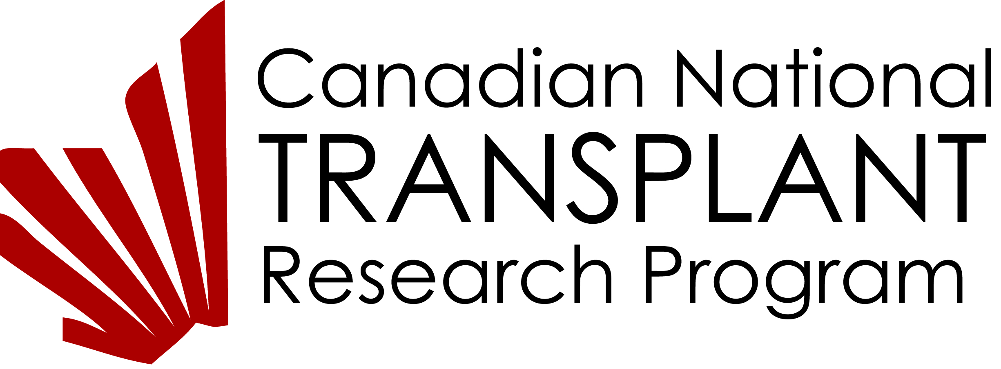
Academic TRAINEE APPLICATION FORM

Description of the Canadian National Transplant Research Program (CNTRP):
The CNTRP is a national initiative designed to increase organ and tissue donation in Canada and enhance the survival and quality of life of Canadians who receive transplants. The CNTRP is the first program in the world to integrate solid organ transplant, hematopoietic stem cell transplant, donation and critical care research communities together in a transformative national research endeavor. The program is led by Drs. Lori West at the Alberta Transplant Institute at the University of Alberta in Edmonton and Marie-Josée Hébert at the Université de Montréal and brings together over 100 investigators and collaborators from across Canada to carry out research and develop resources to help Canadians waiting for cell, tissue or organ transplant.
Description of the CNTRP Training Program:
The CNTRP Training and Career Development Program facilitates the development of competence in transplantation. The technical, clinical, ethical and scientific knowledge and competence needed to fulfill the aims of the CNTRP will be addressed using web-based media, educational conferences and mentorship. This program involves all members of the CNTRP and is composed of two components, the academic training program and the continuous education training program.
All academic trainees within the CNTRP are required to be members of the Training Program, to have an individual training plan with required content, and a mentorship plan for achieving their personal goals. CNTRP trainees are expected to be knowledgeable, dedicated, excellent scholars, with requisite experience for their level of training. They are expected to contribute to the growth and development of Transplant Science, Knowledge and Clinical Application in Canada after their training within the program.
Minimum Requirements:
- Eligibility for academic training at their Canadian University
- Must have a supervisor within the CNTRP
- Must have identified at least one additional mentor, preferably from a different project or core within the CNTRP
- Canadian citizenship or valid student visa
- Able to understand and work in English
Section 1 - Academic and Research Information:
Personal Data
Name
(Surname, First Name, Middle Initial)
Permanent Mailing Address:
Phone:
Email:
Primary Research Supervisor
(must be a CNTRP member):
CNTRP Mentor:
CNTRP Project:
Research Project Title:

Academic Information:
Name of University are you registered with:
Name of the department/faculty:
Indicate the graduate program you are currently registered in: |  | (indicate start date and expected completion date)
 | MSc
 | PhD
 | Post Doctoral Fellow
 | Clinical Research Fellow
 | Surgical fellow
 | Research Associate

Academic History:
Degree | University/Institution | Country | Supervisor | Start Date | End Date
Academic Interruption:
Please use the space provided in this box.
Include relevant academic interruptions in your career progress and provide an explanation indicating the period and reasons for the interruption (i.e. Parental Leave, Bereavement Leave, Sabbatical, Work Experience). Describe how these interruptions have affected your career plan.

Research and other relevant work experience of applicant:
From: (YYYY/MM) | To:  (YYYY/MM) | Position | Institution/Company  City/Country | Supervisor's Name

University Academic Achievements (Prizes, Honors, Awards)
Prizes/Honors/Awards | Awarded by | Local/Provincial  National/International | Year Won

Applicant's Publications:
Attach a list of your 5 most relevant publications.

Applicant's Accomplishments:
Outline any relevant academic, leadership, work and/or research accomplishments and/or experiences that you have accomplished to date. Contributions described in this section may include academic, non-academic and research achievements. Provide background information on major scholarships or awards and their significance.
Please use the space provided in this box.
Applicant's Career Development Plan:
Describe your career goal(s) and how the above listed achievements, publications, awards and related work and research experiences has prepared you to meet your career aspirations. Also, outline the reasons for undertaking the current program of study as it relates to your career progression, your specific career objectives and how your future career plan(s) will be enhanced by the proposed research training experience outlined in this application. Clearly describe and justify the rationale behind the selection of the mentorship advisors and how the mentors relate to your career development plan.
Please use the space provided in this box.
Section 2: Signatures
Candidate:
Primary Research Supervisor:
Mentor:

Section 3: Letters of Reference & Matching Funds
Identify the three individuals who have been asked to submit a letter of reference on your behalf. The primary research supervisor may be one of the three.
Letters of reference should highlight the applicant’s strengths as they relate to the suitability and experience for the proposed work in this training environment (e.g. originality, technical ability, demonstrated skills, judgment, critical skills, etc.) and the benefit that the proposed experience would provide the applicant towards their career goals.
Provide confirmation of matching funds.

Section 4: Research Training Environment
[To be completed by the Primacy Research Supervisor to discuss the Training Environment and the Role of the trainee in the Proposed Research Project.]
Describe in specific detail the resources available to support the applicant’s research and the broad training opportunities the environment provides. Outline the benefit for the applicant training in this environment, highlighting the facilities, and other personnel the trainee will have the opportunity to interact with. Detail the role of the trainee in the proposed research project and how it links to the entire CNTRP.
Please use the space provided in this box.
Section 5: Proposed Research Project
The applicant is to provide a detailed description of the proposed research project for the period during which the award is to be held. Background information should indicate the position and significance of the proposed research within the context of the current knowledge of the field. The research plan outlining the proposed project should state the specific objectives; outline the methodological approach; and the defined key milestones or deliverables to be achieved. Include a description of how the proposed research project aligns with the sub-aim, project or core within the CNTRP.
Please use the space provided in this box.
Section 6: CNTRP Mentoring Plan
Name of the Mentor:
Mentoring goals for the 1st year:
Meeting Schedule:
Proposed benefit of the mentorship:

